SESSION : 22

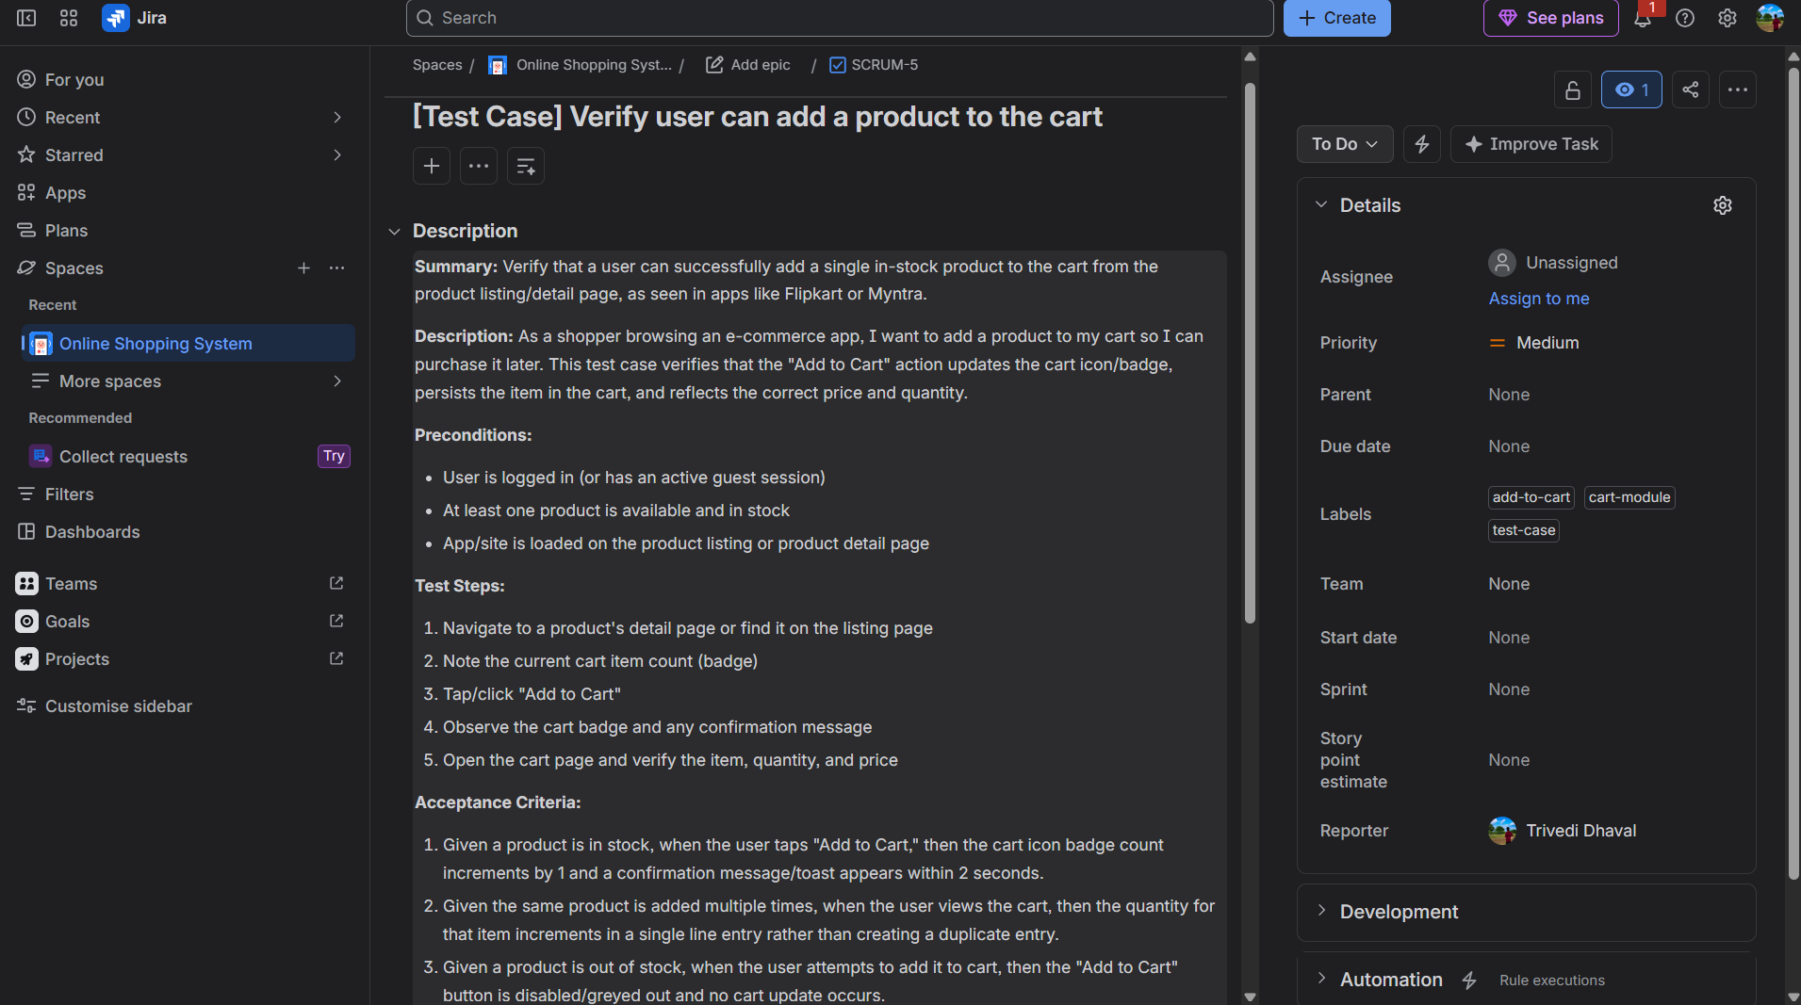
- : Log in to your JIRA test project and create a new test case for the 'Add to Cart' feature found in shopping apps like Flipkart or Myntra, including a clear summary and description.

2. Linking
Once connected, I'd use JIRA's "Link Issue" → "is tested by" (or "relates to") link type, pointing the test case at the parent story/epic (e.g., "SHOP-101: Shopping Cart Module"). Do you know the issue key of that story/epic, or want me to search for it once connected?
4. Acceptance Criteria
- Given a product is in stock, when the user taps "Add to Cart," then the cart icon badge count increments by 1 and a confirmation toast/message appears within 2 seconds.
- Given the same product is added multiple times, when the user views the cart, then the quantity for that item increments rather than creating a duplicate line entry.
- Given a product is out of stock, when the user attempts to add it to cart, then the "Add to Cart" button is disabled/greyed out and no cart update occurs.
5). Epic created: SCRUM-4 "Shopping Cart Module." Now the Add to Cart test case, with acceptance criteria baked into the description.Test case created: SCRUM-5. Now linking it to the Cart epic.Linked SCRUM-5 ↔ SCRUM-4. Now let's create the signup/login test case, then revise it with deeper technical detail.Baseline created as SCRUM-6. Now revising it with technical depth: detailed preconditions, test data, and valid/invalid expected results.Here's what's live in your SCRUM project now:
# | Task | Issue | Status
1 | Add to Cart test case | SCRUM-5 | ✅ Created with summary, description, preconditions, steps
2 | Linked to cart story/epic | SCRUM-4 "Shopping Cart Module" ↔ SCRUM-5 | ✅ Linked
3 | Attachments | — | ⚠️ Not done (see below)
4 | Acceptance criteria | Embedded in SCRUM-5's description | ✅ Done
5 | Signup/login test case revised | SCRUM-6 | ✅ Baseline created, then revised with test data table, preconditions, and 8 valid/invalid/edge scenarios
On attachments (step 3): the JIRA connector I have doesn't expose a file-upload tool, so I can't attach a screenshot or sample data file directly through this integration. Two options:
- You open SCRUM-5 in JIRA and drag in a cart UI screenshot + a CSV/JSON of sample test data (quick, 30 seconds).
- I can generate a sample test-data CSV file right now (product IDs, quantities, prices) for you to download and upload manually.

